From the dashboard, a viewer should be able to learn the following insights as shown above

corresponding to the Department selected by the user:

1. Total employees , Active employees , Average stay duration , Active Remotes , and

average employee age.  


2. Yearly data of Total vs Active Employee  
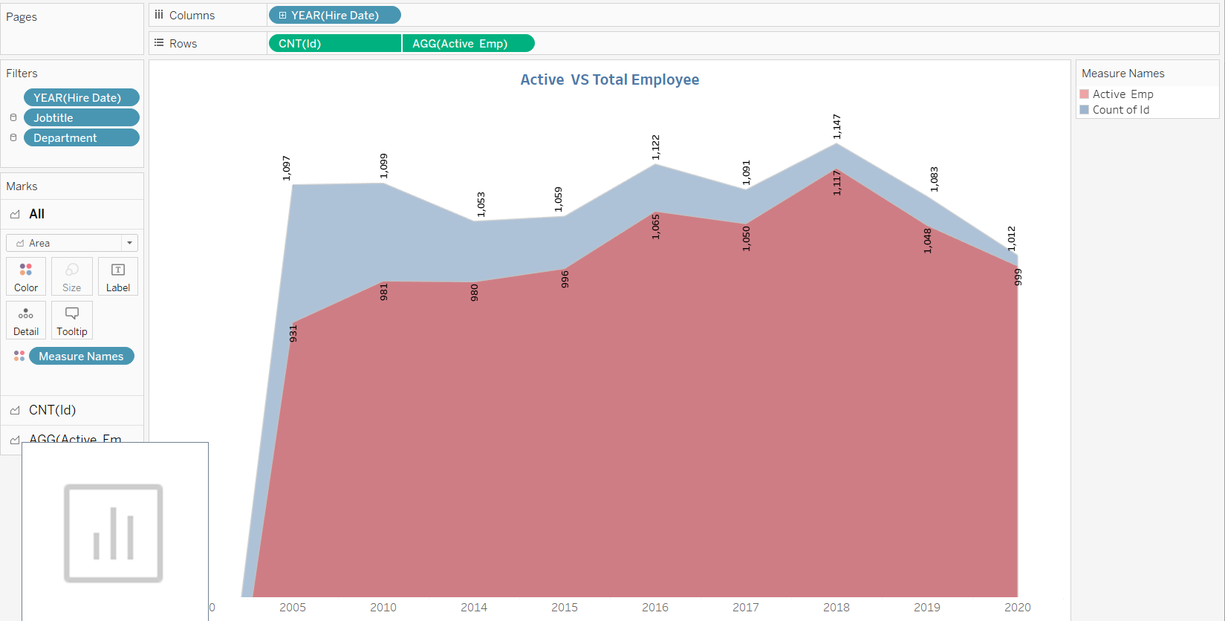

3. Yearly data of Employees that work remotely vs those working at HQ  
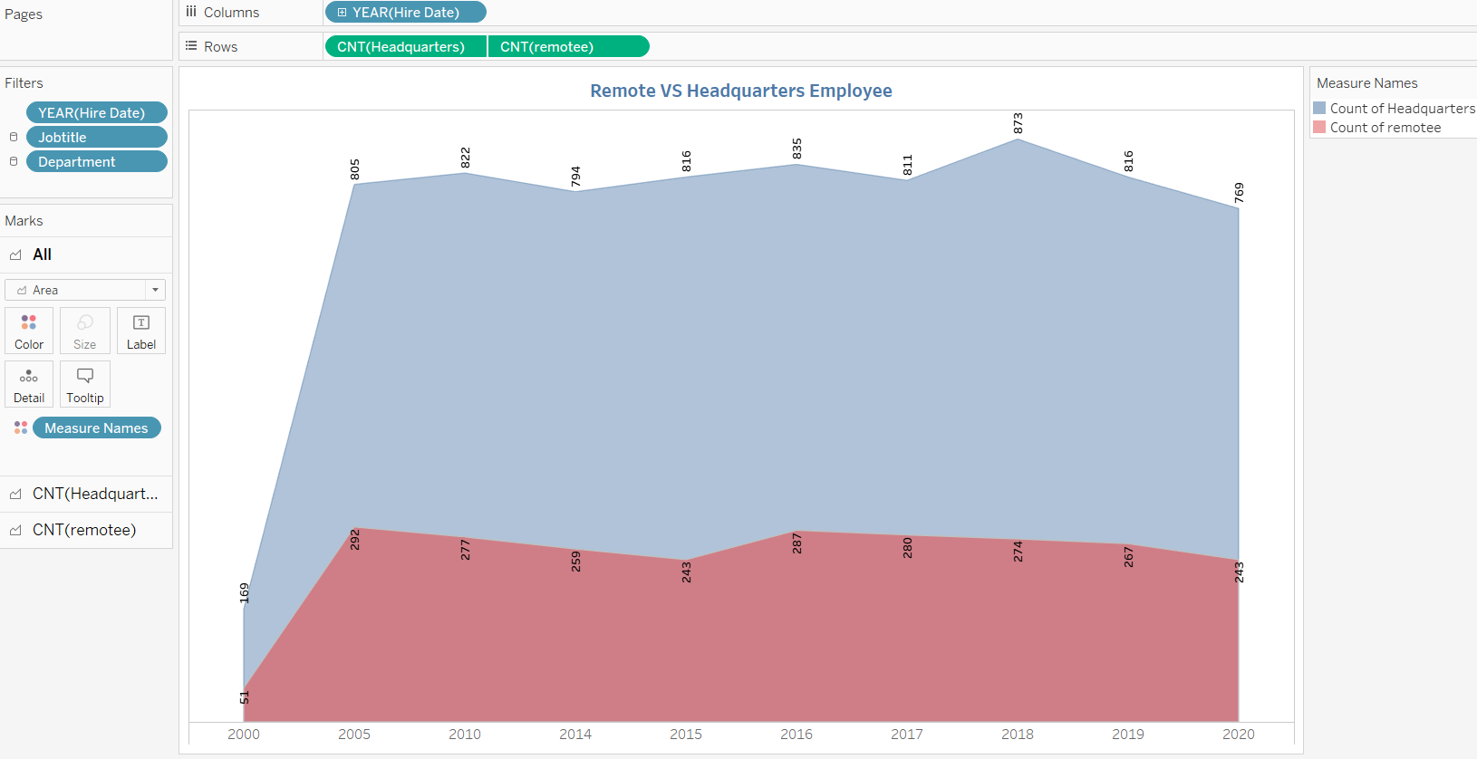

4. Average tenure of different Job Titles  
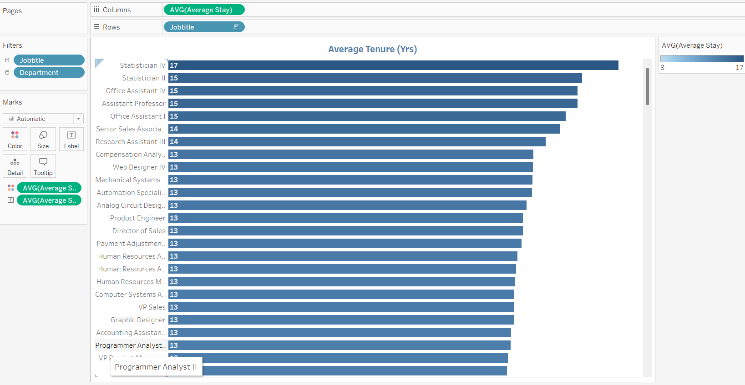

5. Average Age of employees working in different Job Titles

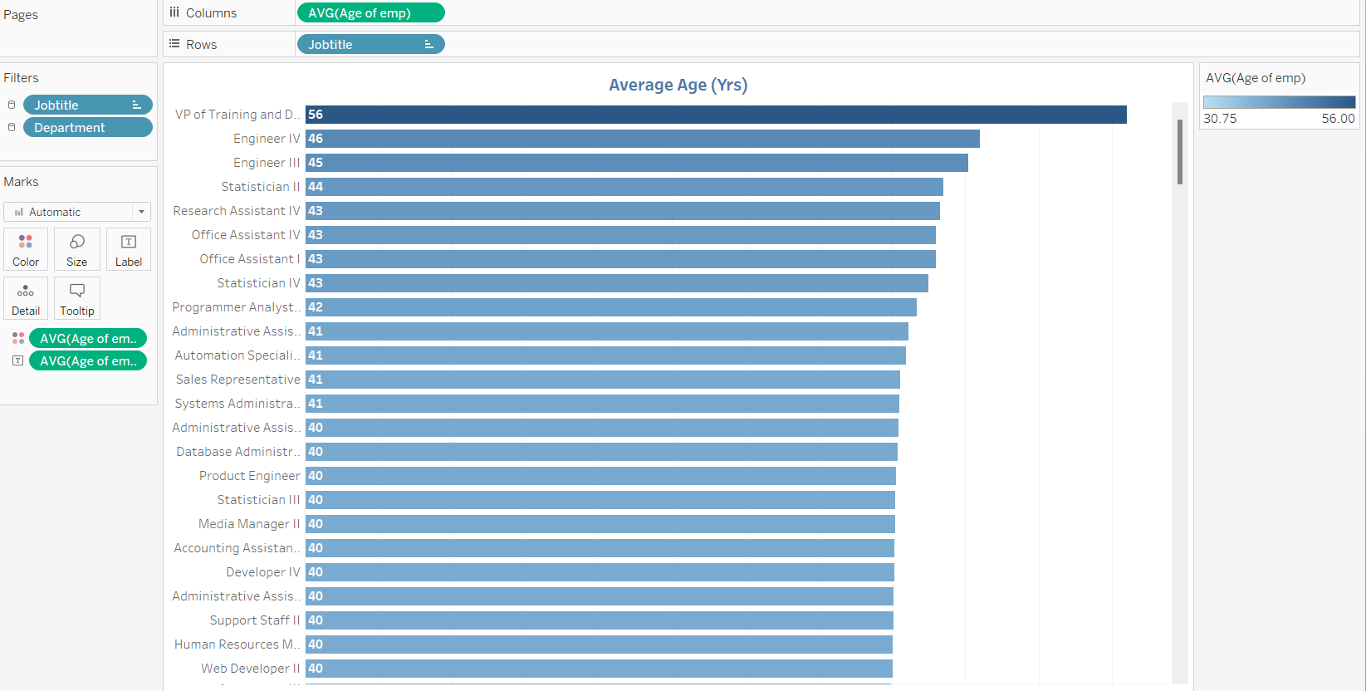

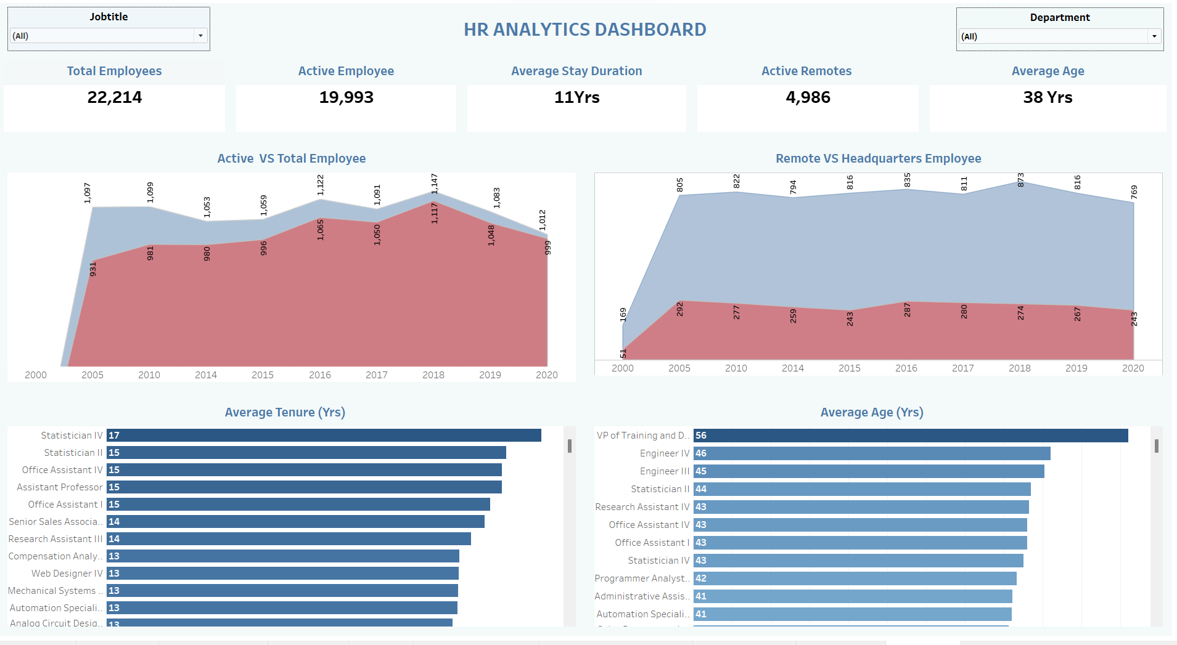

Tableau link 🡪

<https://public.tableau.com/views/HRAnalyticsProjectDashboard/Dashboard1?:language=en-US&publish=yes&:display_count=n&:origin=viz_share_link>